**Lab Mid Q3**

**Syed Farhan Jafri**

**21L-6074**

**BSE-6A**

**Q1) (ip.src == 192.168.1.2 and tcp.dstport == 21) or (ip.src == 195.89.6.167 and (tcp.dstport == 20 or tcp.dstport == 21))  
This shows packet 86 to packet 178 with this filter**

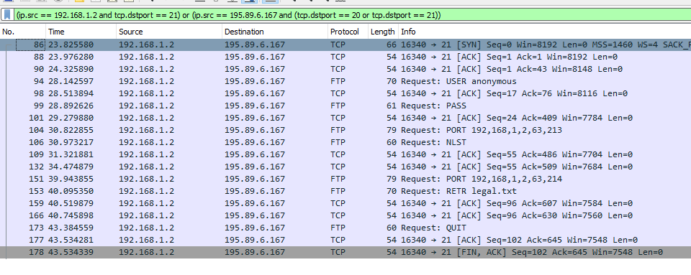

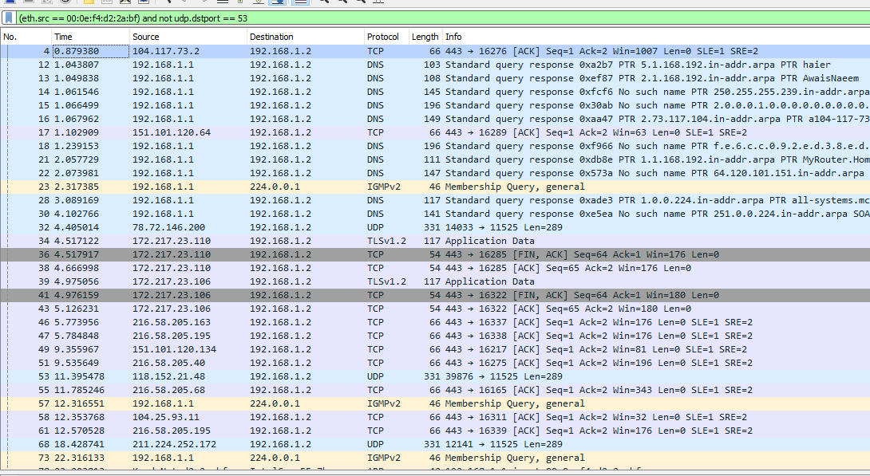**Q2) (eth.src == 00:0e:f4:d2:2a:bf) and not udp.dstport == 53  
This shows packet 4 to packet 189 with this filter**

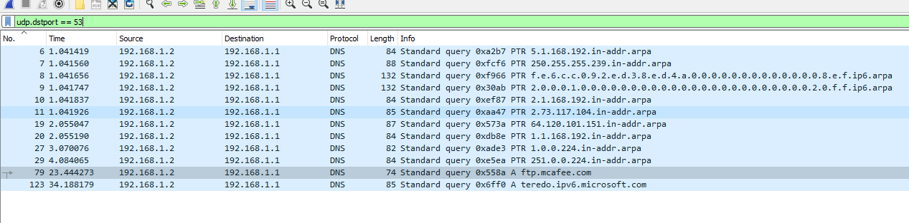**Q3) udp.dstport == 53**acknowledgement number of the DNS request made in Packet No. 12 would be 11 due to 11 packets being received before it.

**Q4) udp && ip.addr == 192.168.1.2  
This ip address filter covers all addresses including 192.168.1.2, 192.168.1.255**

